DEPARTMENT OF ANTHROPOLOGY
Prabhat Kumar College, Contai
Purba Medinipur, West Bengal
Event | Special Lecture in Memory of Prof. Probodh Kumar Bhowmik, an eminent Anthropologist of India.
Date | 29th November 2019
Place | Seminar Hall, (Vivekananda Bhawan), P. K. College, Contai,  Purba Medinipur, West Bengal
Speakers | i) Dr. Tilak Bagchi, Anthropological Survey of India, ii) Prof. Barun Mukhopadhyay, Indian Statistical Institute, iii) Prof. Subir Biswas, Department of Anthropology, WBSU, iv) Dr. P. K. Bhowmik, IIT, Kharagpur, and other respected guests.
Members Present | 88
Photographs | 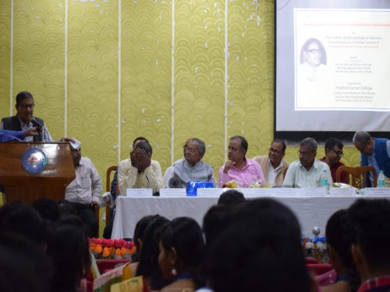 | 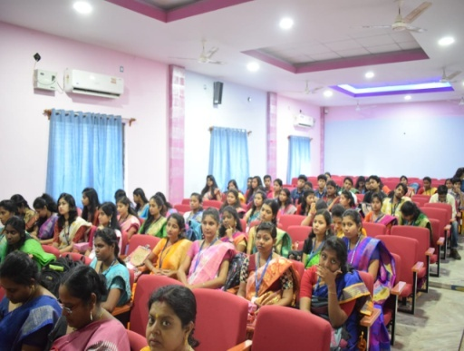 | 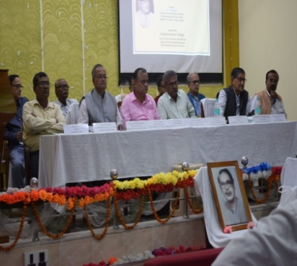
Photographs | 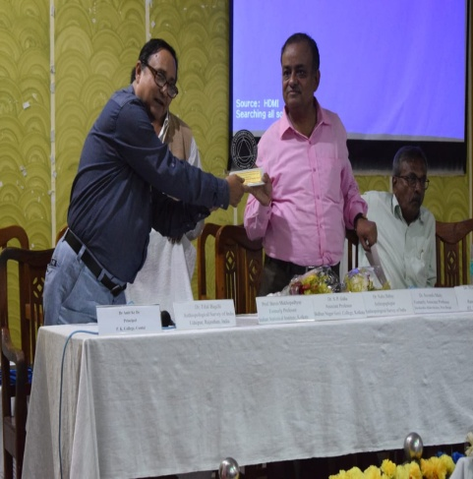 | 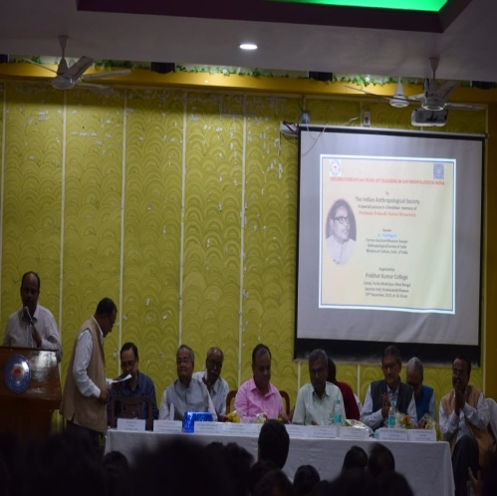 | 