Report on 7 days workshop on " B.Ed practicum" for 1st semester students
With an objective to acquaint the students with knowledge of practicum related to topics prescribed under the curriculum designed by curriculum committee, constituted by the Higher Education Department, Government of West Bengal following NCTE Regulations , P.K College Contai organized a 7 days workshop for B.Ed students in the seminar hall of the B.Ed department, P.K College Contai from 15th February,2022 to 23rdMarch 2022 under the jurisdiction of the College Principal,Dr.Amit kumar Dey and under the coordinatorship of the head of the Teacher's Training Department Dr.Amit kumar Bera along with the joint collarboration of all faculties members of the said department.
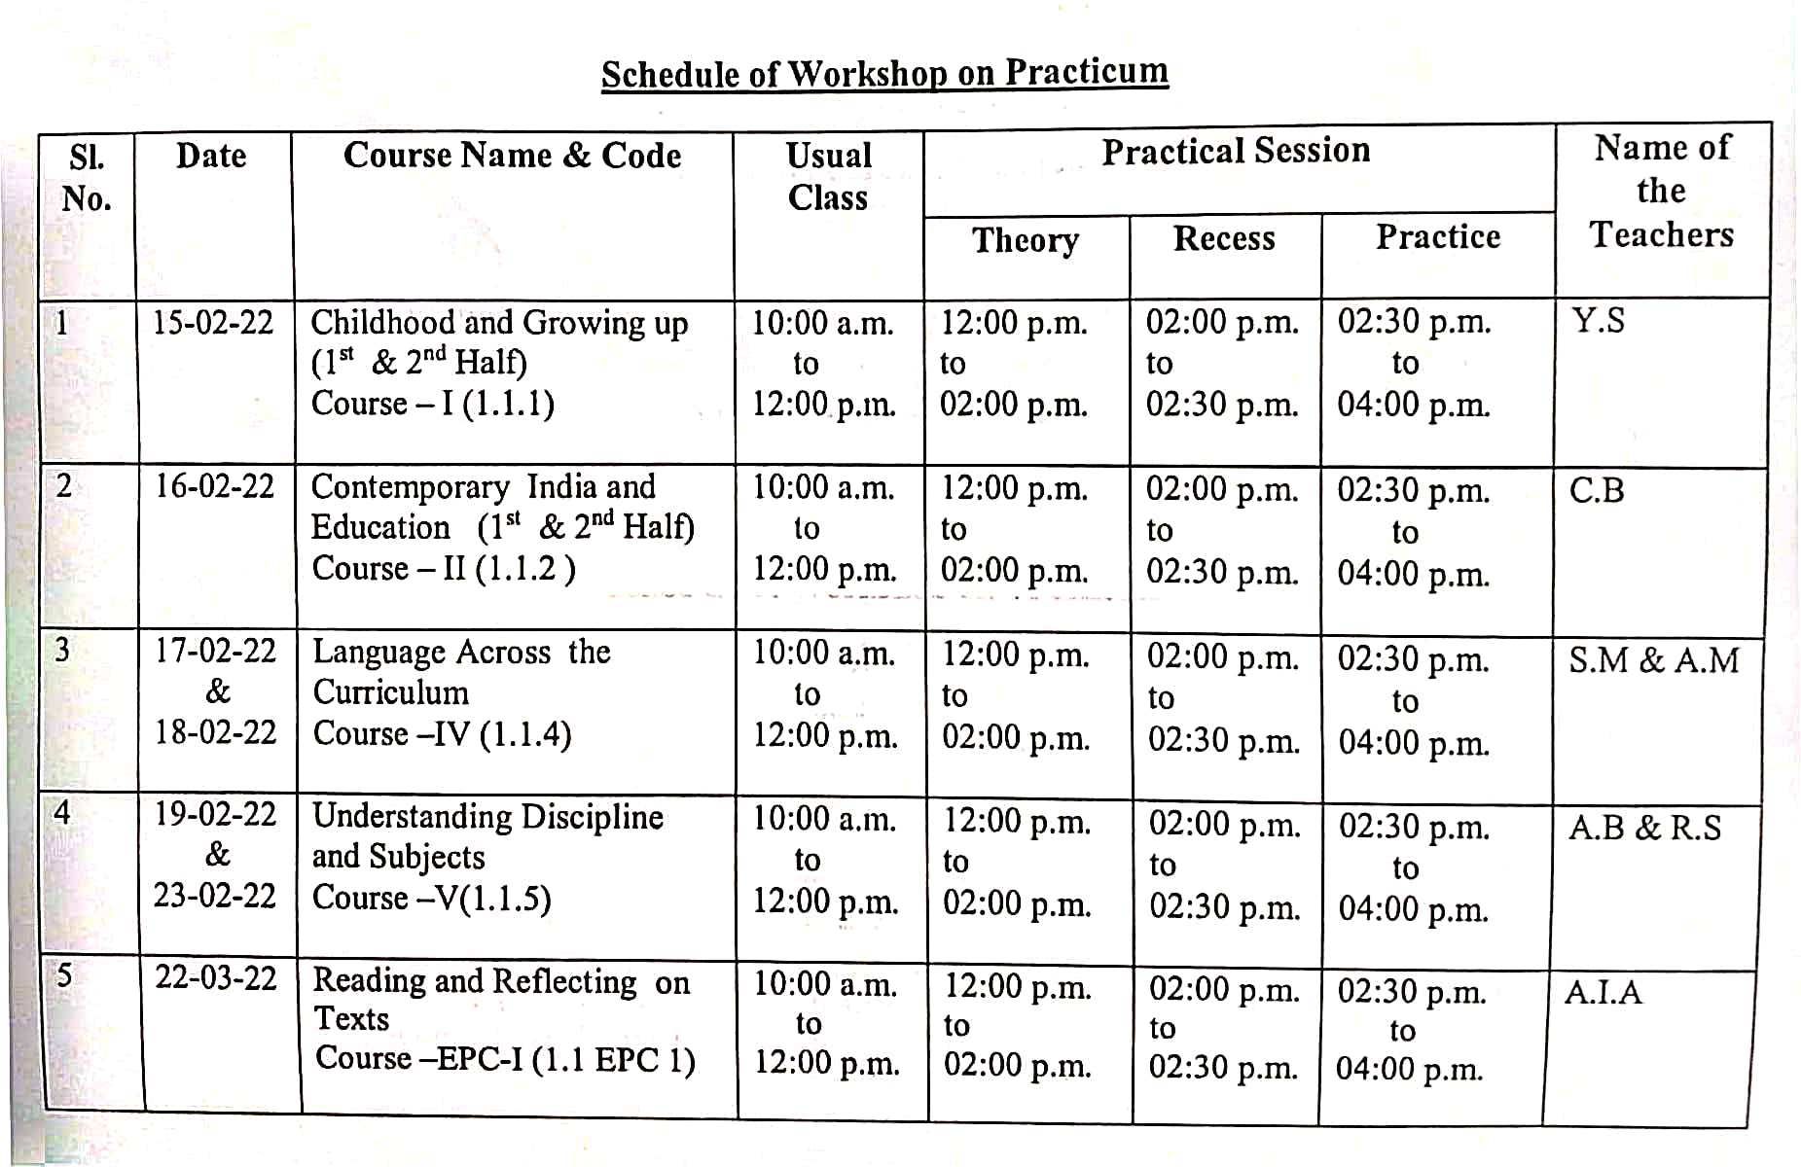
A glimpse of the resource persons and their qualitative lectures delivered topics in the workshop is given as follows:
The event was successful one. The workshop was relevant to the title and were well appreciated by the students. After completion of this workshop students have left encouraged to explore these areas further.

